**Level 1 Eliza**

1. Research the “ELIZA Computer Therapist Program”. Summarize your answers to the following:
   1. What does the program do?

This program imitates a Rogerian psychologist that talks to people about their personal problems but actually just answered the question asked in different wording.

* 1. When and why was the program created?

ELIZA was created in 1966 and it was created for people to have someone to talk to about their personal problems and “trick” them.

* 1. How does the program work?

Eliza asks you how you are and what you may want to talk about today and when you ask her questions she asks you to tell her more when she can’t rearrange your input into output. Basically Eliza doesn’t really answer your questions or help you in any way because she just takes your input and changes the wording and sends it back as output.

1. Use an on-line version of the ELIZA program to see what it is like.
   1. Open the URL : <http://psych.fullerton.edu/mbirnbaum/psych101/Eliza.htm>
   2. Begin by talking about your feelings (just like if you were talking to a guidance councillor).
   3. After a while, try to trick the program.
2. In what ways did the program seem like you were talking to a real person? What was a strategy used by the program to keep the discussion going?

It just kept saying tell me more about your problem which I think was a reason why the conversation was continuing. The program seemed like a real person because if you were to go to a real psychologist, they ask you similar questions.

1. In what ways could you tell that it was not a real person? What were some of the weaknesses of the program?

I could tell it was not a real person because Eliza was not able to come to a conclusion on how to fix my problem and sometimes she gave answers that made no sense at all. For example if I tell her I don’t want to talk to her she says I see and then if I tell her goodbye she says tell me more which doesn’t make sense at all in this context.

1. If you had your friend talk to ELIZA but did not tell them it was a program, how long do you think it would take for them to figure it out? Explain your answer.

Not long to be honest because she wasn’t giving proper answers when I told her my problem. For example, 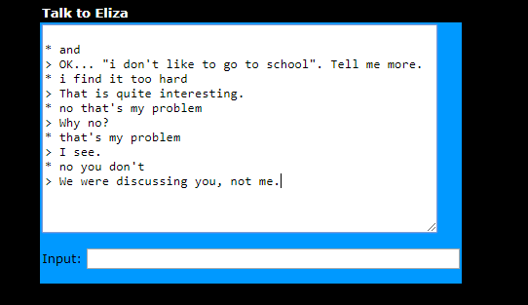

This was a part of the beginning of the conversation that I had with Eliza and she wasn’t making much sense so I think anyone can easily tell that she is not real.

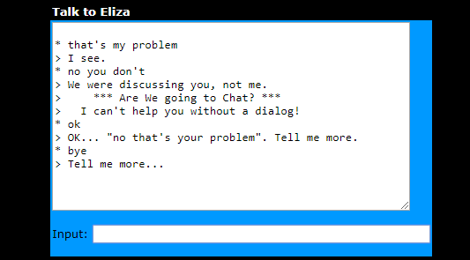

This was the second part to the same conversation.

**Level 2 Turing Test**

1. Research the “Turing Test”. Summarize your answers to the following:
   1. What is the Turing Test?

The Turing Test is a method of inquiry determining whether or not a computer is capable of thinking like a human being.

* 1. Who was Alan Turing?

Alan Turing was a British scientist and a pioneer in computer science. He had helped break the German Enigma code in World War II and also laid the groundwork for modern computing and theorized about artificial intelligence.

* 1. How does the Turning Test work?

The Turing Test is a test in which the computer must fool a human into believing that they are human too.

* 1. How is the Turing Test different from other Artificial Intelligence tests?

1. Visit the Ted Ed website to learn more about the Turing Test.
   1. Watch the video at: <https://ed.ted.com/lessons/the-turing-test-can-a-computer-pass-for-a-human-alex-gendler>
   2. Complete the on-line test at: <https://ed.ted.com/lessons/the-turing-test-can-a-computer-pass-for-a-human-alex-gendler#review>
2. Has any computer AI passed the Turing Test? Research this question and report on your results.

No computer AI has been able to pass the Turing Test. I think one of the reasons no computer AI has been able to pass this test is because computers lack emotions.

1. Do you think that you have ever been fooled by an on-line computer AI program? Explain your answer.

No, I don’t think I have ever been fooled by an on-line computer AI program because every person I’ve talked I know in real life so I know that they are humans. But yes I have talked to some people who I don’t know but they seemed pretty real to me from their conversation and pictures.

**Level 3 Article reviews**

Pick any three (3) out of the following four (4) articles to read and review. Answer the questions that are specific to each article.

Article 1: Social Media Bots

Read the following article:

<https://www.questia.com/magazine/1G1-530914703/social-media-bots-how-they-spread-misinformation>

1. How much internet traffic is estimated to be produced by AI bots?

It’s estimated that about 30% of internet traffic is produced by AI bots.

1. What are some strategies used by bots to appear more human?

They:

-Used emojis in their posts.

-Only posting at reasonable hours of the day.

-Limiting the amount of information they share.

1. How many social media accounts are estimated to be AI bots?

As of 2014, it has been estimated that about 8.5& of all Twitter’s users are bots and it has been estimated that in 2017, it may have gone up to about 15%.

1. How easy is it for a user to detect that they have been “friended” by a social media AI bot?

Not as easy because most users who accept bot request are those users that accept random requests from people or people in disguise.

Article 2: Social Media Bots

Read the following article:

<https://www.usnews.com/news/healthiest-communities/articles/2018-07-24/how-social-media-bots-could-compromise-public-health>

1. How many social media accounts are estimated to be AI bots?

Tens of millions of social media accounts are estimated to be AI bots.

1. What is the purpose / objective of these AI bots?

They can be used to spread misleading false information with the intent of influencing how people think or act.

1. How could a bot be used to increase the number of people vaping or smoking?

Bots usually post hashtags about smoking and e-cigarettes in the same tweet meaning bots were pushing vaping as a safe alternative to traditional tobacco cigarettes.

1. How could a bot be used to increase the public concern about getting vaccinated?

Millions of messages and memes with comments about how vaccinations are harmful show that it can only be the work of bots.

1. What is a “sockpuppet”?

They are fake or deceptive accounts manages by real people who post provocatively to anger and distract others.

Article 3: Automated Journalism

Read the following article:

<https://www.bbc.com/news/business-42858174>

1. What are some of the topics of the articles produced by the robo-journalists owned by the Press Association (PA)? How long and how detailed are these articles?

Anything from crime statistics to how many babies are being born out of wedlock. These articles are no more than several paragraphs or so in length and they are usually very detailed and do not require any additional information.

1. “At this stage” what are the limitations of robo-journalists? What jobs do human journalists do that cannot yet be done by robo-journalists?

The system’s output is a job that human journalists do that robo-journalists can’t do as of yet.

1. What happened when the LA Times used a robo-journalist to report on an earthquake?

The earthquake was actually a record of an earthquake that happened in 1925. This created a false alarm.

1. What are some of the “easier” tasks that robo-journalists are used to produce articles for?

The automated part is one of the tasks that robo-journalists are used for to produce articles.

1. Do you think this article was written by a robo-journalist? Explain your answer by giving examples of both why and why not.

No I don’t think this was written by a robo-journalist. I think this because in this robot-journalists, like the cons to them are stated very clearly. So I don’t think that a robo-journalists would post a article about why they are not a good idea.

Article 4: Automated Journalism

Read the following article:

<https://digiday.com/media/washington-posts-robot-reporter-published-500-articles-last-year/>

1. What is the name of the Washington Post’s robo-journalist and what was its first assignment?
2. How can robo-reporting expand the audience for newspapers?
3. How can robo-reporting help human journalists?
4. Are smaller news organizations using robo-reporting? What are the benefits to smaller organizations?
5. Do you think this article was written by a robo-reporter? Explain your answer by giving examples of both why and why not.

Social Media Bots

<https://www.questia.com/magazine/1G1-530914703/social-media-bots-how-they-spread-misinformation>

<https://www.usnews.com/news/healthiest-communities/articles/2018-07-24/how-social-media-bots-could-compromise-public-health>

Automated Journalism

<https://www.bbc.com/news/business-42858174>

<https://digiday.com/media/washington-posts-robot-reporter-published-500-articles-last-year/>

Will Artificial Intelligence take your job?

<https://www.forbes.com/sites/forbestechcouncil/2018/02/26/artificial-intelligence-will-take-your-job-what-you-can-do-today-to-protect-it-tomorrow/#430f57bf4f27>

<https://www.forbes.com/sites/theyec/2018/07/06/do-you-fear-artificial-intelligence-will-take-your-job/#7fb127a611aa>